Supplementary material:
On the measurement of dimensionality of biodiversity
Richard D. Stevens and J. Sebastián Tello

Univariate Analyses
One important point of interest is the correlations among indices that characterize redundancy across the phenotype of biodiversity. In addition, were interested in strength of correlations relative to expectations based on underlying variation in species richness of grid cells. In a number of cases relationships among indices were nonlinear, so we used Spearman rank correlations to assess magnitude of association. We used two null models to generate expected values of biodiversity given the underlying number of species present in each cell (See methods). From 1000 iterations of each of these null models we generated distributions of expected correlations between indices of biodiversity. If an empirical correlation coefficient fell outside of the middle 95% of the correlations produced by a particular null model we concluded that that correlation was different than expected given underlying gradients in numbers of species. Orthogonal dimensions of biodiversity vary independently of each other and thus should produce correlations of low magnitude. Thus, correlations among indices of biodiversity of lower magnitude reflect higher dimensionality than correlations of high magnitude.
Low multivariate dimensionality of biodiversity was well visualized by analyses of pairwise relationships based on the original data. Forty-three of 45 correlations were significantly different than null expectations based on the incidence-equiprobable model (Fig. S1) and 41 of 45 correlations were significantly different based on the incidence-fixed null model. Typically, empirical magnitude was significantly greater than magnitude of expected correlations. This was not the case when spatial and nonspatial datasets were analyzed. For both datasets empirical correlations were more similar to those expected from the incidence-fixed than the incidence-equiprobable null models (Fig. S2). Nonetheless, the way empirical correlations were related to those expected by the incidence-equiprobable null models were very different. For the spatially structured data set, empirical correlations were often of significantly greater magnitude than those expected whereas for the nonspatial data set empirical correlations were often of significantly lower magnitude.

Sensitivity Analyses
The perceived dimensionality of diversity can depend on the particular combination and number of indexes used to measure it. To test whether our results are driven by our particular combination of indexes, we conducted a sensitivity analysis.
First, we created new combination of biodiversity indices by randomly removing between 1 and 5 (50%) of the 10 original indices. Using this subset of variables, we repeated PCA and null model analyses. We then estimated a standardized effect size, which measures the degree of dimensionality in the empirical data when compared to the dimensionality expected by the null models. The standardized effect size was based on Camargo’s evenness metric, and was calculated as the difference between the observed and the mean of the null values, divided by the standard deviation of the null values:
$$C_{SES}=\frac{C_{obs}-{\overline{C}}_{null}}{σ_{null}}$$
A negative standardized effect size indicates that the evenness is lower in the empirical datasets, implying higher correlations among variables and lower dimensionality that expected given the species richness gradient.
We repeated this procedure for 500 randomly created subsets of biodiversity indices. If conclusions were sensitive to the particular subset of variables used, then we expect to find at least some cases where the empirical evenness was greater than the null - contradicting our results with the full subset of variables.
In contrast to this expectation, however, standardized effect sizes for all subsets of variables were negative (Fig. S3), and typically were more negative than for the full set. This confirms our conclusions that the observed dimensionality is less than expected given the species richness gradient, and that this conclusion is true independently of the subset of variables used.
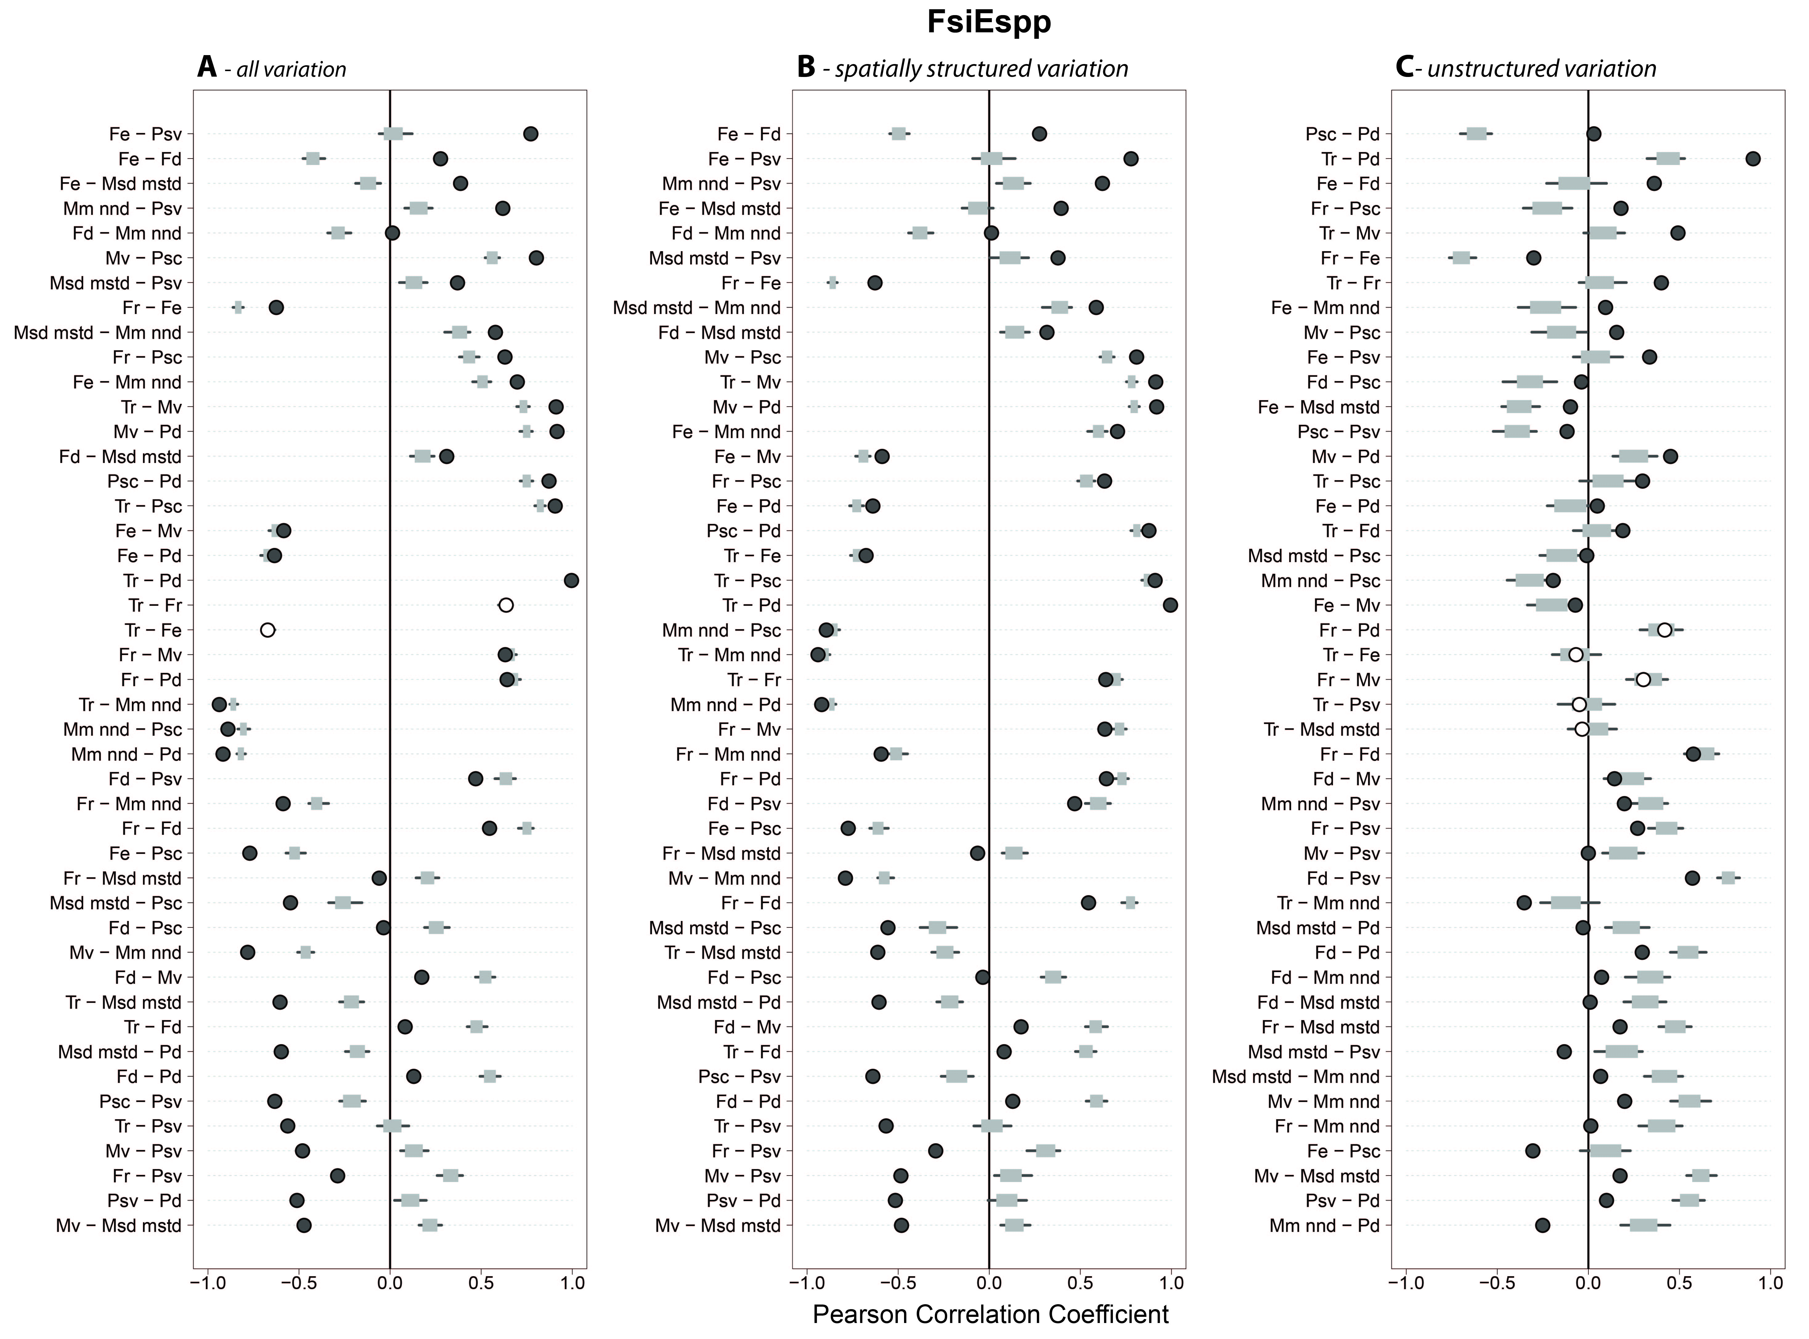
Figure S1. Results of equiprobable-incidence null model analyses for pairwise correlations among indices. Black lines represent the range of correlation coefficients calculated for diversity gradients among 1000 runs of the null model. Grey rectangles represent the region in which 95% of the randomized correlations fell. Dots represent the position of the empirical correlation relative to the distribution of null model generated correlations. Dark gray dots represent empirical correlations that are significantly different than the null model. White dots represent empirical correlations that are not different from null model expectations. Acronyms: Tr-taxonomic richness, Fr- richness of functional groups, Fe-evenness of functional groups, Fd-divesity of functional groups, Mv-morphological volume, Msd mstd-standard deviation of morphological minimum spanning tree, Mm nnd-morphological mean nearest neighbor distance, Psc-phylogenetic species clustering, Psv-phylogenetic species variability, Pd-phylogenetic species diversity
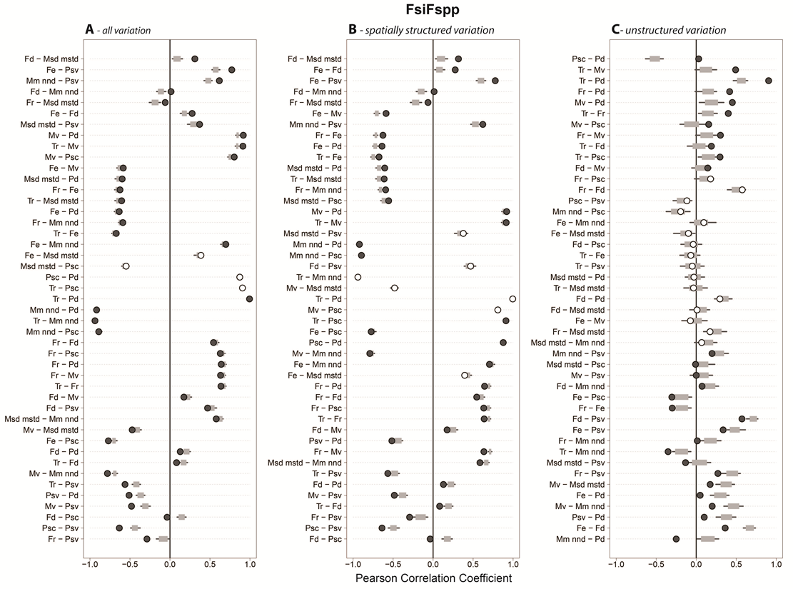
Figure S2. Results of fixed-incidence null model analyses for pairwise correlations among indices. Black lines represent the range of correlation coefficients calculated for diversity gradients among 1000 runs of the null model. Grey rectangles represent the region in which 95% of the randomized correlations fell. Dots represent the position of the empirical correlation relative to the distribution of null model generated correlations. Dark gray dots represent empirical correlations that are significantly different than the distribution of null model generated correlations. White dots represent empirical correlations that are not different from null model expectations. Acronyms: Tr-taxonomic richness, Fr- richness of functional groups, Fe-evenness of functional groups, Fd-divesity of functional groups, Mv-morphological volume, Msd mstd-standard deviation of morphological minimum spanning tree, Mm nnd-morphological mean nearest neighbor distance, Psc-phylogenetic species clustering, Psv-phylogenetic species variability, Pd-phylogenetic species diversity.

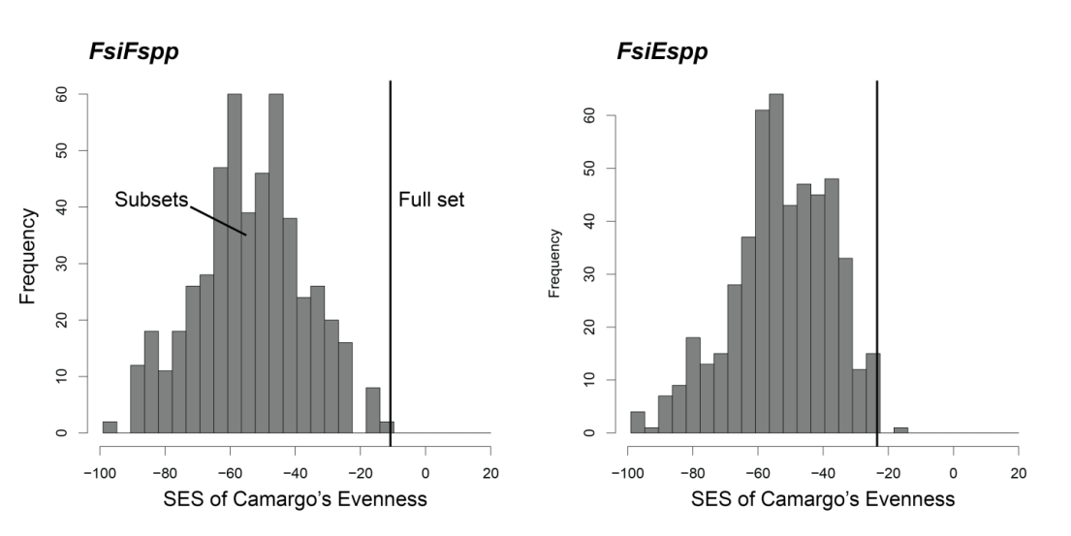
Figure S3. Results of sensitivity analyses confirming that any subset of biodiversity indices would lead to the same conclusion reached with the full set presented in the body of the manuscript. The black vertical line shows the standardized effect size of Camargo’s evenness index for the full set of 10 diversity indices. The histogram shows the variation in the standardized effect sizes across 500 different subsets of diversity indices. In all cases, dimensionality was significantly less than expected by the null models, supporting our conclusions.

